Follow Path Development Package Function

Based on the basic navigation and positioning scheme, it helps to manage the output of log information issued by multiple tasks passing through points. The planned path is saved in .csv format in a local file.This function pack will automatically publish the coordinates of each path point, and automatically adjust the deceleration distance. Reduce frequent acceleration and deceleration during execution. The adjustment method is that the linear path releases the coordinate of the next target point in advance, so that the sweeper will not slow down for the current target point (the process is similar to that the current target point has not been reached, the deceleration process has not begun, and the next target point has been released); Under the curve path, the current strategy is not to release the target point in advance (it will slow down to 0 before going to the next target point), so as to achieve the maximum path fitting. The function package will also release the execution log, which will record the path through this execution and the execution of each path (successful arrival or not, and path fitting). If the program determines that the robot is stuck, the feature pack automatically ends execution.

Follow path development packages depend on conditions
Before testing the package, the RVIZ and simulation environment should have the following capabilities::

1. Release and execute basic navigation objectives. When RVIz releases 2D_NAV_GOAL, the simulator should be able to execute:
• Global route planning
• Local route planning
• Plan new local routes when obstacles appear
• Execute routes and avoid obstacles.
All navigation, route planning, and obstacle avoidance parameters should be completed before testing Follow Path.
2. The simulation environment should be able to publish ODOM topic, and the relative displacement of each reference frame should be specified in TF. The program calls the TF Listener, which basically says that the different frames of the sweeper should publish their positions at a certain frequency. This is probably the step in setting up the sensor.

Method of confirmation: Run rqt, which should have the following topic

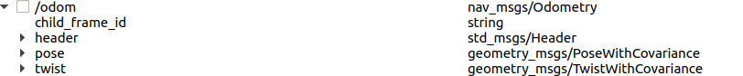

Follow path development package operation, and important parameters

Operation method:
roslaunch follow_waypoints follow_waypoints.launch
If you are prompted that the file cannot be found, you may need to build and run it in the following folder:
“chmod +x follow_waypoints.py”
“chmod +x mileage_tracker.py”

There are:
chmod +x follow_waypoints

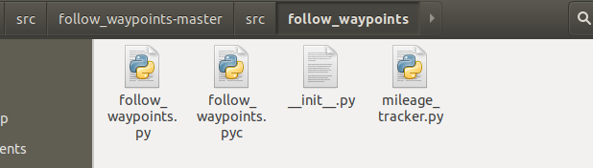

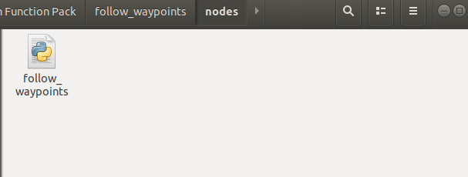

Path definition method:
- CSV defined (generated by path planner)
- Or rviz add ( As shown in the figure below, the second 2D Nav Goal can be used to define the path multiple times to set the store as a list. Wait for the command to be executed by the feature pack management. The first 2D Nav Goal is simple by default)

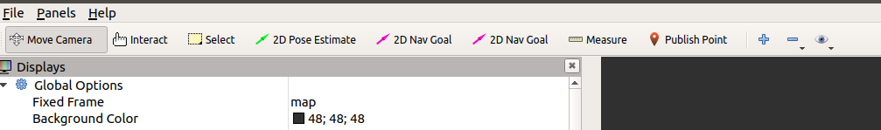
Adding continuous navigation paths with RVIz requires modifying the default rVIz definition file. To find the rviz file corresponding to the launch file, for example, my launch file is called as follows: args="-d $(find robot_navigation)/rviz/multi_navigation.rviz"/>

Add the following in the appropriate place inside:
“/2D Nav Goal2”

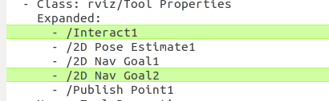

“ - Class: rviz/SetGoal
Topic: /goal”

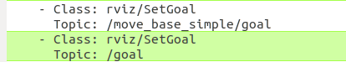

The generated stop point coordinates are displayed in RVIZ:
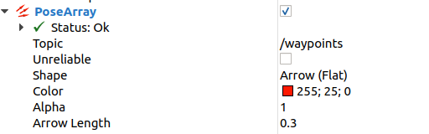

Run path command
rostopic pub /start_journey std_msgs/Empty -1

Important parameters:

Input parameters (default values can be changed in the launch file):
- Smooth_tolerance: Assumes that adjacent path points are on the same line (A, B and C), so A can issue tasks to C within A certain distance from B. When smooth_tolerance is 0.0 (currently the default), the car slows down before reaching point B, stops at point B, and the task issues to point C. The larger the value is set, the more deceleration can be avoided, but if it is too large, it may cause inaccurate path fitting. Meanwhile, it is also related to the adjacent distance of A, B and C, for example, if the distance between A, B and C is 0.5m and smooth_tolerance is 1m, A and B will directly jump to point C.
- deviation_tolerance: In the process of debugging the motion parameters and path planning parameters of our disinfection robot, it is ideal that the robot should strictly fit the path. However, when the parameters in the early stage are not ideal, there will be a far difference between the trajectory and the planning parameters, which will also occur in the obstacle avoidance process. When "go far" exceeds the value of this parameter, console will givewarn message “"Path Follow Is Not Successful, expected traveling %s m, real travelling %s m" ”

Output parameters:
The execution path and the path execution log are stored in the following locations:
Pose. CSV is the path specified by the upper computer. The program first loads the coordinates in this file.
Outputpose. CSV is the execution diary.
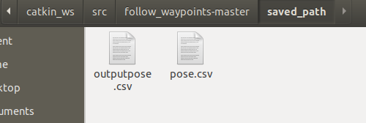

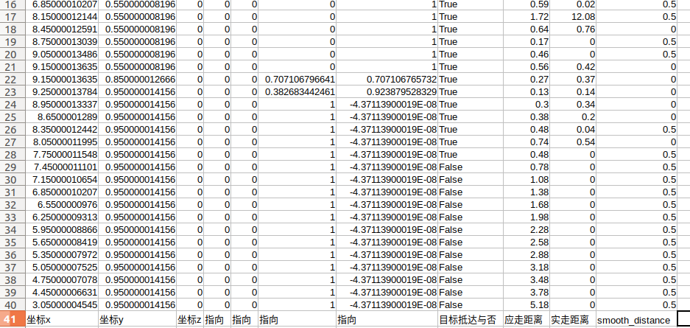
Perform diary reads as defined above.
When Smooth_distance is 0.5 (the default value of smooth_tolerance in this experiment is 0.5), it indicates that the path is straight. 0 indicates that the path is curved.
At the end of the program, the car cannot reach the target point for ten consecutive times, which proves that the car has been stuck. Program forced exit.
The required distance and actual distance, as well as the smooth strategy executed, can show how the path fits, and whether the car "oscillates" walking.

